Takeovers Panel

Annual Report 2022–23

© Commonwealth of Australia 2023

ISSN 2204‑0854 (Print)  
ISSN 2204‑0862 (Online)

**Ownership of intellectual property rights in this publication**

Unless otherwise noted, copyright (and any other intellectual property rights, if any) in this publication is owned by the Commonwealth of Australia (referred to below as the Commonwealth).

**Creative Commons licence**

With the exception of the Coat of Arms (see below) and the Takeovers Panel logo this publication is licensed under a Creative Commons Attribution 3.0 Australia Licence.

CC by_grey

Creative Commons Attribution 3.0 Australia Licence is a standard form licence agreement that allows you to copy, distribute, transmit and adapt this publication provided that you attribute the work. A summary of the licence terms is available from:

<http://creativecommons.org/licenses/by/3.0/au/deed.en>.

The full licence terms are available from:

<http://creativecommons.org/licenses/by/3.0/au/legalcode>.

The Commonwealth’s preference is that you attribute this publication (and any material sourced from it) using the following wording:

Source: Licensed from the Australian Government Takeovers Panel under a Creative Commons Attribution 3.0 Australia Licence.

The Australian Government Takeovers Panel does not necessarily endorse third party content of this publication.

**Use of the Coat of Arms**

The terms under which the Coat of Arms can be used are set out on the Department of the Prime Minister and Cabinet website (see [http://www.pmc.gov.au/government/  
commonwealth‑coat‑arms](http://www.pmc.gov.au/government/commonwealth-coat-arms)).

A copy of this document appears on the Takeovers Panel website. The website address is: [www.takeovers.gov.au](http://www.takeovers.gov.au).

Printed by CanPrint.

|  |  |  |
| --- | --- | --- |
|  | Level 16, 530 Collins Street  Melbourne VIC 3000 | |
| Telephone:  Internet:  Email: | 03 9655 3500  [www.takeovers.gov.au](file:///C:/Users/KAD/AppData/Local/Microsoft/Windows/Temporary%20Internet%20Files/Content.Outlook/GKIA9E5M/www.takeovers.gov.au)  [takeovers@takeovers.gov.au](mailto:takeovers@takeovers.gov.au) |

23 August 2023

The Hon Dr Andrew Leigh MP

Assistant Minister for Competition, Charities and Treasury

Parliament House  
Canberra ACT 2600

Dear Assistant Minister

**ANNUAL REPORT 2022–23**

In accordance with section 183 of the *Australian Securities and Investments Commission Act 2001*, I submit the 2022–23 Annual Report of the Takeovers Panel for presentation to Parliament.

Yours sincerely

Alex Cartel signature


Alex Cartel  
President

Table of Contents

Part 1 – Background 1

Who we are 1

Our website 2

Who to contact 2

Review by the President 3

Panel at a glance 2022–23 6

Part 2 – The Panel 7

Other features 8

Organisational structure 9

Panel President 9

Acting Presidents 10

Panel Executive 10

The Office 11

Appointment of Panel members 12

Part 3 – The Work of the Panel 19

Matters 19

Issues in applications 22

Ensuring consistency 23

Guidance 23

Consultation 24

Legislation 24

Judicial review 24

Part 4 – Performance Reporting 25

Matter reviews 25

Industry liaison 25

Referrals to ASIC 25

Website 26

Announcements and media releases 26

Corporate governance 26

Outcome and output information 26

Financial information 28

Part 5 – Management and Accountability 31

External scrutiny 31

Management of human resources 31

Purchasing 34

Consultants 34

Small business 34

Discretionary grants 34

Advertising and market research 34

Environmental performance 34

Freedom of information 35

Regulatory Impact Statements 35

Appendix 1 – Panel members 36

Appendix 2 – Sub‑committee members 38

Appendix 3 – Panel Applications 39

Appendix 4 – Abbreviations and acronyms 41

List of tables

[Table 1: The Panel’s dispute resolution functions 7](#_Toc146790808)

[Table 2: Appointment of Panel members during 2022–23 12](#_Toc146790809)

[Table 3: Outcome of applications received by the Panel, 2022–23 20](#_Toc146790810)

[Table 4: Time to decision by the Panel, 2022–23 21](#_Toc146790811)

[Table 5: Issues raised in applications, 2022–23 22](#_Toc146790812)

[Table 6: Consultation papers issued, 2022–23 24](#_Toc146790813)

[Table 7: Summary resource statement 27](#_Toc146790814)

[Table 8: Income statement (Showing Net Cost of Services) (unaudited) for the year ended 30 June 2023 28](#_Toc146790815)

[Table 9: Operative staff by classification and gender 32](#_Toc146790816)

[Table 10: Members of the Panel at 30 June 2023 36](#_Toc146790817)

[Table 11: Members appointed to the Panel in 2022–23 37](#_Toc146790818)

[Table 12: Members who ceased their membership of the Panel in 2022–23 37](#_Toc146790819)

[Table 13: Sub‑committees 38](#_Toc146790820)

[Table 14: Applications received by the Panel in 2022–23 39](#_Toc146790821)

[Table 15: Outcomes of review applications received by the Panel in 2022–‍23 40](#_Toc146790822)

List of charts

[Chart 1: The Panel’s organisation structure 9](#_Toc146790823)

[Chart 2: Panel members by Profession at 30 June 2023 12](#_Toc146790824)

[Chart 3: Panel members by Location at 30 June 2023 13](#_Toc146790825)

[Chart 4: Panel members by Gender at 30 June 2023 13](#_Toc146790826)

[Chart 5: The Panel’s process for applications for declarations of unacceptable circumstances 19](#_Toc146790827)

Index of Compliance

[Letter of Transmittal iii](#_Toc143688565)

**Aids to access**

[Table of contents iv](#_Toc143688565)

Contact 2

Website 2

Abbreviations and acronyms 41

Alphabetical index 42

**Review by the President** [**3**](#_Toc143688565)

**Overview of the Panel**  [**7**](#_Toc143688565)

**Performance reporting 25**

Performance statements 6, 20

Financial performance and statements 28

**Management and accountability 31**

Corporate governance 26

External scrutiny 31

Management of human resources 31

Purchasing 34

Consultants 34

Small business 34

Executive remuneration 32

Advertising and market research 34

Discretionary grants 34

Commonwealth disability strategy 33

Freedom of information 35

Regulatory Impact Statements 35

# 

# Part 1 – Background

## Who we are

The Takeovers Panel is a peer review body[[1]](#footnote-2) established as ‘*a specialist body largely comprised of takeover experts’* [[2]](#footnote-3) that is the main forum for resolving disputes in takeovers.[[3]](#footnote-4) It consists at 30 June 2023 of 52 specialists in mergers and acquisitions – investment bankers, lawyers, company directors and other professionals.

The Panel, established in January 1991, underwent changes to its structure and role in March 2000. It operates under:

* Part 6.10 of the *Corporations Act 2001* (Cth) (Corporations Act)
* Part 10 of the *Australian Securities and Investments Commission Act 2001* (Cth) (ASIC Act)
* Part 3 of the *Australian Securities and Investments Commission Regulations 2001* (Cth) (ASIC Regulations).

## Our website

The Panel’s website ([www.takeovers.gov.au](http://www.takeovers.gov.au)) includes:

* media releases
* reasons for decisions and an index of decisions
* a description of the Panel and its operations and a guide to the takeover provisions in the Corporations Act
* Guidance Notes
* consultation papers
* Procedural Rules
* privacy policy
* annual reports
* legislative resources and other background material relating to mergers and acquisitions
* the Panel’s Information Publication Scheme.

Interested persons may subscribe to the Panel’s website to be notified when new items are posted.

## Who to contact

Enquiries regarding this report may be directed to:

Mr Allan Bulman  
Chief Executive, Takeovers Panel  
Level 16, 530 Collins Street  
Melbourne VIC 3000  
Telephone: +61 3 9655 3500  
Email: [takeovers@takeovers.gov.au](mailto:takeovers@takeovers.gov.au)

|  |  |
| --- | --- |
| **Mr Alex Cartel President of the Panel**  **Mr Alex Cartel President of the Panel** | Review by the President During the 2022–23 financial year, the Panel consulted on updates to Guidance Note 7: Lock‑up devices[[4]](#footnote-5) and Guidance Note 19: Insider Participation in control transactions. The Panel published the results of these consultations, and issued revised versions of these guidance notes, on 8 August 2023.  The Panel has on issue 18 Guidance Notes to assist market participants to understand the principles and policies that the Panel will consider in deciding applications. I would like to thank the executive and the relevant sub‑committees for all their work in updating these important guidance notes. |

In recent years, there have been examples of target company boards agreeing to exclusivity arrangements without a fiduciary out when providing due diligence access in the non‑binding bid stage. The revised Guidance Note 7 provides guidance on when such arrangements may be unacceptable, as well as other aspects in the non‑binding bid stage. This is an example of the Panel amending its guidance to address emerging market practices.

The Panel re‑launched its website in December 2022. The website now has the capacity for Panel applications to be made online via the website and an enhanced search function. The website also contains a wealth of historical material. I would like to thank Tania Mattei and the executive team for all the work they have put into making the website so user friendly. The executive is now working on further improvements to the website, including an enhanced index of reasons (which will have the capacity to be updated more frequently) and further improvements to the search function.

During the financial year the Panel received 16 applications. While this was materially below the historical average, the Panel conducted proceedings in 68.75% of applications received which was well above the historical average and reflected the complex factual nature of the matters during the year. As a result, the average number of days to decision across all matters was affected. Given the fewer applications, lengthy proceedings (particularly those that involve consideration of a large amount of material and complex facts) can affect the average number of days to decision. For example, in The Market Herald Limited, the Panel had to review a large quantity of documents, and lack of cooperation from parties, in determining whether certain shareholders were associates. The Panel also conducted a conference and sought an extension of time from the Court under section 657B. If this matter was excluded, the average number of days to decision for the year would be 24.3 as opposed to 29.1 calendar days for all matters.

Completing most matters in less than one month compares favourably with most courts and tribunals both here and overseas. However, it is important for the Panel to continue to find ways to ensure that its decisions are as speedy, fair and correct as possible. The Panel this financial year will review its Procedural Guidelines, Guidance Note 2: Reviewing Decisions, Guidance Note 4: Remedies General and matter procedures to (among other things) discourage disruptive party behaviour, minimise legal costs for parties and streamline decisions to decline to conduct proceedings where appropriate.

The Panel recognises the important role it plays in ensuring the efficient, competitive and informed market for corporate control. Being accessible and transparent to parties in need of its services is central to this. The Panel and the executive are committed to taking further steps to enhance the profile of the Panel so that a wider range of parties are aware of its existence and the role it can play in resolving disputes in a speedy, fair and commercial manner.

When a Panel application is made, I (or an Acting President) usually appoint an investment banker, lawyer and someone with corporate experience from the Panel membership who are free of conflicts to consider the matter. The Courts have on several occasions recognised the Panel members’ commercial experience as an important part of the Panel’s decision‑making process.[[5]](#footnote-6) Accordingly, it is important for the Panel’s operations to have sufficient Panel members with the right balance of experience and diverse backgrounds. At 30 June 2023, the Panel had 52 part‑time members, 27 of whom were women.

In March this year the government appointed 8 highly credentialed Panel members and they have already made a strong contribution to the Panel. Over the coming years there will likely be considerable renewal of the Panel membership with many long serving Panel members concluding their third or fourth terms. A focus for the Panel and executive in the 2023–24 financial year will be to ensure that the experience of long‑serving Panel members is shared with the broader Panel to ensure a smooth transition of knowledge among the Panel members. I thank members for their work throughout the year, as participants in sitting Panels, at Panel days, on policy sub‑committees and on post‑matter reviews.

The Panel members and I greatly appreciate the support of the executive. The executive continues to make themselves available to parties who wish to give post matter feedback and to stakeholders generally.

The Panel continues to be grateful to the Federal Government and the Department of the Treasury for their commitment to a robust, principles‑based Panel regime and for their ongoing support.

I am pleased to report on our performance for the 2022–23 financial year.

Alex Cartel signature


Alex Cartel  
President

## Panel at a glance 2022–23

|  |  |  |
| --- | --- | --- |
| Applications  (average 28.3 per year since 1 July 2000) |  | 16 |
|  | | |
| Matters the Panel conducted proceedings in  (average 54.32% since 13 March 2000) |  | 68.75% |
|  | | |
| Matters where the Panel accepted undertakings |  | 1 |
|  | | |
| Matters where the Panel made declarations and orders  \*plus one declaration and undertakings |  | 1\* |
|  | | |
| Average calendar days between application and decision[[6]](#footnote-7)  (average 17.4 since 13 March 2000) |  | 29.1 |
|  | | |
| Average calendar days between decision and publication of reasons  (average 34.4 since 13 March 2000) |  | 34 |

# Part 2 – The Panel

The Panel improves the certainty, efficiency and fairness of Australia’s takeovers market by:

* resolving disputes in a fair, timely, consistent, informal and sound manner
* publishing clear, well‑developed guidance.

The Panel’s two main dispute resolution functions are considering whether unacceptable circumstances exist[[7]](#footnote-8) and reviewing certain decisions of ASIC.[[8]](#footnote-9)

Table 1: The Panel’s dispute resolution functions

|  |  |  |
| --- | --- | --- |
|  | Unacceptable circumstances | Review of ASIC decisions |
| What | Deciding applications for a declaration of unacceptable circumstances is the main work of the Panel | The Panel may, on application, review ASIC decisions under Chapter 6 and, during a takeover bid, Chapter 6C |
| How | The Panel (comprising three members) considers the circumstances against the principles in section 602, the provisions and policy of Chapter 6 and the public interest | The Panel may exercise all the powers of ASIC under Chapters 6 and 6C[[9]](#footnote-10) |
| Guidance | Guidance Notes, Procedural Rules, legislative policy of Chapter 6, previous decisions | Regulatory Guides, ASIC policies, reasons for ASIC’s decision, Panel policy |

Table 1: The Panel’s dispute resolution functions (continued)

|  |  |  |
| --- | --- | --- |
|  | Unacceptable circumstances | Review of ASIC decisions |
| Outcomes | If a declaration is made the Panel can make any orders to address the unacceptable circumstances, including a ‘remedial order’[[10]](#footnote-11) | Affirm, vary, set aside (and substitute/remit) the ASIC decision |
| Review | The Panel, on application, conducts a merits review of a decision of the initial Panel.[[11]](#footnote-12) A review Panel comprises three different members to the initial Panel. There may be only one review of a Panel decision | As the Panel proceeding is the merits review, there is no review Panel |
| How often | In the current period there were 13 applications for a declaration at first instance and three applications for review | In the current period there were no applications for review of an ASIC decision |

## Other features

The Panel may make rules, not inconsistent with the Corporations Act or the Corporations Regulations, to clarify or supplement the operation of the provisions of Chapter 6.[[12]](#footnote-13) It has not made any rules under this power.

The Panel has a power to make Procedural Rules.[[13]](#footnote-14) It published revised Procedural Rules in 2021.

The Panel may decide a matter referred from the Court.[[14]](#footnote-15) There were no referrals in the current period.

## Organisational structure

Chart 1: The Panel’s organisation structure

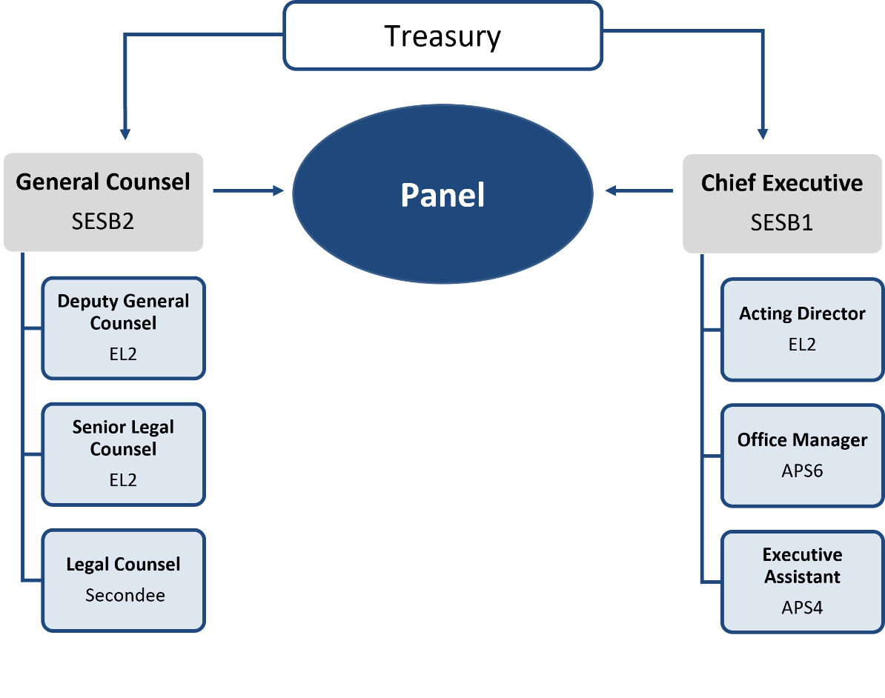

## Panel President

Mr Alex Cartel, a member of the Panel, is its President.[[15]](#footnote-16) His responsibilities include:

* liaising with the Minister, Government, Treasury and stakeholders
* appointing members to constitute sitting Panels
* considering the interests of sitting Panel members for possible conflicts
* participating in reviewing the performance of the executive.

He regularly sits on matters.

## Acting Presidents

The following members have been appointed[[16]](#footnote-17) to act as President when the President cannot act:

* Mr Richard Hunt
* Ms Michelle Jablko
* Mr Ron Malek
* Ms Yasmin Allen AM
* Ms Tracey Horton AO
* Ms Diana Nicholson.

## Panel Executive

The executive assists Panel members make consistent, timely and commercial decisions. It provides:

* administrative and legal support for Panel members
* communication with parties in proceedings
* liaison with market practitioners, ASIC’s takeovers staff and ASX
* an interface to prospective parties (for example, discussing issues and providing a perspective on takeovers policy as it may apply to current takeovers).

During the financial year the Panel executive comprised:

* Chief Executive, Mr Allan Bulman
* General Counsel, Ms Tania Mattei
* Deputy General Counsel, Ms Katrina Fong (on long term leave)
* Deputy General Counsel, Mr Andrew Bubniw
* Senior Legal Counsel, Ms Melanie Gilbert (part‑time)
* Acting Director, Mr Andre Fontanini
* Legal Counsel, secondees. The Panel’s normal process is to staff its office, in part, with secondees from major law firms. During the financial year, the secondees were Ms Kirsty Hall (DLA Piper, Perth) and Mr Hugh McDonald (MinterEllison, Melbourne). The secondees have ably assisted the executive. The Panel appreciates their contributions and the willing support of their firms.
* two administrative staff: Ms Karolina Ksiezak as Office Manager and Ms Rebecca Andrewartha as Executive Assistant.

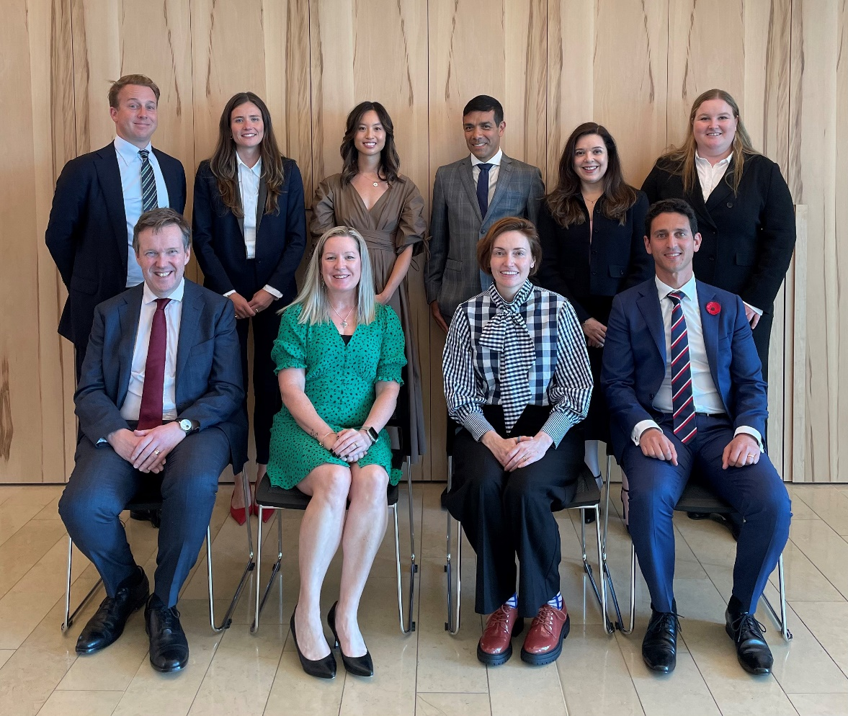

**The President with the executive**: (L to R Top) Hugh McDonald, Melanie Gilbert, Katrina Fong, Alex Cartel, Tania Mattei, Kirsty Hall. (L to R Bottom) Allan Bulman, Rebecca Andrewartha, Karolina Ksiezak, Andre Fontanini.

## The Office

The Panel is co‑located with the Department of the Treasury’s Melbourne office at Level 16, 530 Collins Street.

## Appointment of Panel members

Table 2: Appointment of Panel members during 2022–23

|  |  |  |
| --- | --- | --- |
| Reappointments (9) | Appointments (9) | Terms completed (8) |
| Ms Yasmin Allen AM  Ms Michelle Jablko  Mr Christian Johnston  Ms Kristen Jung  Mr Michael Lishman  Ms Rebecca Maslen‑Stannage  Ms Diana Nicholson  Mr Neil Pathak  Mr James Stewart | Mr Carl Blanchard  Ms Sylvia Falzon  Mr Joseph Fayyad  Ms Louise Higgins  Dr Ruth Higgins SC  Ms Emma‑Jane Newton  Dr Kristina Stern SC  Ms Erin Tinker  Ms Kate Towey | Ms Paula Dwyer  Ms Karen Evans‑Cullen  Mr Ian Jackman SC  Mr Anthony Jarvis  Mr Robert McKenzie  Ms Tara Page  Dr Kristina Stern SC  Mr David Williamson |

Members are appointed on a part‑time basis, usually for three years, by the Governor‑General on the nomination of the Minister.[[17]](#footnote-18) State and Territory Ministers may submit nominations to the Minister. Members are nominated on the basis of their knowledge and experience in one or more of the fields of business, administration of companies, financial markets, financial products and financial services, law, economics and accounting.[[18]](#footnote-19) A mix of expertise, geographical representation and gender representation is also considered.

Chart 2: Panel members by Profession at 30 June 2023

Bar chart of Panel members by profession; 16 bankers, 17 corporate and 19 lawyers.


Chart 3: Panel members by Location at 30 June 2023

Bar chart of Panel member location; 26 Sydney, 15 Melbourne, 4 Perth, 3 Brisbane, 2 Adelaide, 1 Tasmania and 1 New Zealand. 


Chart 4: Panel members by Gender at 30 June 2023

Bar chart of Panel members by gender; 25 male and 27 female.


### Members’ biographies (as at 30 June 2023)

Alex Cartel (President) – Head of Banking, Capital Markets and Advisory at Citi Australia & New Zealand. Member since 2015.

Yasmin Allen AM (Acting President) – Chairman of Digital Skills Organisation and Tic:Toc Online, non‑executive director of QBE Insurance, Cochlear Limited, Santos Limited, ASX Limited and The George Institute for Global Health. Member since 2017.

Kelvin Barry – Managing Director and Co‑Head of Advisory and Capital Markets, Australasia at UBS AG. Member since 2016.

Robin Bishop– Managing Partner at BGH Capital, director of the Burnet Institute for Medical Research and AFL Commissioner. Member 2011–2014 and re‑appointed 2016.

Carl Blanchard– Chair of New Zealand Takeovers Panel and Partner at PwC New Zealand. Member since 2022.

Michael Borsky KC–Barrister and National Competition Councillor. Member since 2019.

Constantine Boulougouris–Partner at MinterEllison, Co‑Head of the M&A/Capital Markets Team. Member since 2022.

James Burchnall – Director at Kain Lawyers, leader of Public M&A and Equity Capital Markets practice. Member since 2022.

Stephanie Charles – Deal Partner and Head of Capital Markets at BGH Capital. Member since 2015.

Alberto Colla–Partner at MinterEllison. Member since 2022.

Bruce Cowley – Non‑executive director of Australian Retirement Trust, Sunshine Coast Hospital and Health Service and Chair of the Queensland Trust for Nature. Adjunct Professor University of Queensland. Member since 2016.

Chelsey Drake – Partner at Allens. Member since 2016.

Teresa Dyson – Non‑executive director of Seven West Media, Genex Power, LGIAsuper, Energy Queensland, Shine Justice and Entyr. Member since 2018.

Sylvia Falzon– Non‑executive director of Suncorp Group and Premier Investments. Chairman of Cabrini Health Australia. Member since 2023.

Joseph Fayyad– Australian Chief Executive Officer of Bank of America. Member since 2023.

Marissa Freund–Managing Director and Head of Mergers & Acquisitions (Australia & New Zealand) at Goldman Sachs. Member since 2019.

Elizabeth Hallett – Non‑executive director of Lynch Group Holdings Limited, Australian Retirement Trust Pty Ltd, Australian Registry Investments Pty Ltd, Clayton Utz and the Civil Aviation Safety Authority, and member of the advisory board of The John Sample Group. Member since 2013.

Louise Higgins– Managing Director, Suncorp Integration, ANZ Bank. Non‑executive director of Enero Group. Member since 2023.

Ruth Higgins SC–Barrister, Senior Vice President of the NSW Bar Association and director of the Law Council of Australia. Member since 2023.

Tracey Horton AO (Acting President) – Non‑executive director of The GPT Group, IDP Education and CLV FM. Member since 2015.

Richard Hunt (Acting President)–Chairman Fort Street Capital and Chairman Fort Street Real Estate Capital. Member since 2012.

Michelle Jablko (Acting President) – Chief Financial Officer of Transurban Limited. Member since 2014.

Christian Johnston–Advisory Director at Goldman Sachs, Australia & New Zealand. Member since 2014.

Kristen Jung–Global Head of Legal and Executive Director at Macquarie Capital and Sydney University Master of Laws Lecturer in Takeovers and Reconstructions. Member since 2020.

Marina Kelman – Executive Director at Goldman Sachs. Non‑executive director of Baker Heart and Diabetes Institute. Member of the finance committee of the State Library of Victoria. Member since 2021.

Bill Koeck – Deputy Chairman and Lead Independent Director of Coronado Global Resources Inc and non‑executive director of Poulos Group and Nick Scali Limited. Member since 2015.

Jeremy Leibler – Partner at Arnold Bloch Leibler, non‑executive director of Thorney Technologies Limited. Member since 2015.

Michael Lishman – Partner at Hamilton Locke. Member since 2020.

Timothy Longstaff – Non‑executive director of Aurizon Holdings Limited, Snowy Hydro Limited, Ingham’s Group Limited, Perenti Limited and The George Institute for Global Health. Member since 2022.

Sandy Mak – Partner, Head of Corporate/M&A at Corrs Chambers Westgarth. Member since 2021.

Ron Malek (Acting President)–Founder and Executive Co‑Chairman of Luminis Partners, member the UNSW Council’s Investment Committee. Member since 2012.

Rebecca Maslen‑Stannage – Global Chair and Senior Partner at Herbert Smith Freehills. Member since 2017.

Denise McComish–Non‑executive director of Webjet Limited, Macmahon Holdings Limited, Gold Road Resources Limited, Synergy, Beyond Blue and Chair, Advisory Board, School of Business and Law at Edith Cowan University. Member since 2013.

John McGlue–Managing Director of Castle Gates Australia. Member since 2019.

Bruce McLennan – Managing Director and Co‑Head of Advisory at Gresham Advisory Partners. Member since 2016.

Rory Moriarty–Partner at Clayton Utz. Member since 2018.

Kerry Morrow – Director at Laity Morrow and non‑executive director of Tennis SA. Member since 2019.

Emma‑Jane Newton– Managing Director at Morgan Stanley and Chair of Sydney Dance Company. Member since 2023.

Diana Nicholson (Acting President) – Partner, Financial Services Sector Leader at King & Wood Mallesons, Trustee Melbourne & Olympic Parks Trust, Director Care Australia Limited. Member since 2017.

Tony Osmond – Chairman, Banking, Capital Markets and Advisory at Citi Australia & New Zealand, non‑executive director of The Australian Ballet. Member 2011–2014 and re‑appointed 2015.

John O’Sullivan – Chairman of Serendipity Capital Holdings Limited, Chair of Abacus Storage King and non‑executive director of The Lottery Corporation Limited. Member 2005–2011 and re‑appointed 2018.

Deborah Page AM– Non‑executive director of Brickworks Limited, Growthpoint Properties Australia and The Star Entertainment Group Limited. Member since 2022.

Neil Pathak– Partner and Head of M&A (Australia) at Ashurst, Senior Fellow of the University of Melbourne Law School. Member since 2017.

Karen Phin – Non‑executive director of Omni Bridgeway and ARB Corporation. Member since 2015.

Sarah Rennie – Co‑Head of Investment Banking Australia and Head of Equity Capital Markets at Jarden Australia. Member since 2015.

John Sheahan KC– Barrister. Member 2014–2020 and re‑appointed 2021.

James Stewart–Partner at DLA Piper, non‑executive director of The Splendid Gin, Caledon Estate owner. Member since 2020.

Philippa Stone–Joint Global Head, Capital Markets and Partner at Herbert Smith Freehills, Deputy Chair of the Centre for Independent Studies, Advisory Council Member, Asia Society. Member since 2019.

Erin Tinker – Founding Partner at Barrenjoey. Member since 2023.

Kate Towey– Partner at Allens. Member since 2023.

Nicola Wakefield Evans AM – Non‑executive director of Macquarie Group, Lendlease Corporation, Viva Energy Group Limited, Clean Energy Finance Corporation, MetLife Insurance Limited, MetLife General Insurance Limited and GO (Goodes O’Loughlin) Foundation. Chair of 30% Club Australia. Member since 2015.

Sharon Warburton – Non‑executive director of Wesfarmers, Northern Star Resources, Blackmores, Worley, Thiess Group Holdings, Mirvac Funds Management Australia and Karlka Nyiyaparli Aboriginal Corporation. Member since 2015.

# Part 3 – The Work of the Panel

## Matters

The Panel resolves matters as quickly and as informally as a proper consideration of the issues permits. Timeliness remains one of the key performance indicators for the Panel. Proceedings are generally conducted in private because of commercial sensitivity and time constraints. The Panel has the power to invite or accept submissions from any person and to call for persons to make submissions.

The following chart maps the Panel’s usual process in relation to applications for declarations of unacceptable circumstances.

Chart 5: The Panel’s process for applications for declarations of unacceptable circumstances

Flowchart diagram of the Panel’s process for applications for declarations of unacceptable circumstances.  
1. Application - Advise market
2. President – Makes interim orders (if urgent) – Advise market – Appoint sitting Panel
3. Panel – Receive preliminary submissions
4. Conduct Proceedings – No - Advise parties and market – Application for review (only with President’s consent) – Publish reasons – Post matter review
5. Conduct proceedings – Yes – Consider interim orders or vary previous interim orders – Issue brief – Submissions and rebuttals
6. Unacceptable circumstances – No – Advise parties and market – Application for review (only with President’s consent) – Publish reasons – Post matter review
7. Unacceptable circumstances – Yes – Issue proposed declaration and supplementary brief on final order – Submissions and rebuttals – Declaration and Orders – Publish decision and final orders – Application for review - Publish reasons – Post matter review


The Panel usually receives material voluntarily from parties in response to a Panel brief. The Panel has the power to convene a conference[[19]](#footnote-20) and summon witnesses to give evidence and provide documents.[[20]](#footnote-21) During the 2022–2023 financial year the Panel convened one conference and summoned one witness.

Further description of the Panel’s processes can be found on its website.

Appendix 3 lists the applications in the current period (16 in total). Table 3 groups the applications by outcome and Table 4 shows the time frame to decision. Table 5 groups applications by subject matter.

Table 3: Outcome of applications received by the Panel, 2022–23

|  |  |  |
| --- | --- | --- |
| Form of resolution | Number of matters | Comments |
| Declaration and Orders | 1 | Circumstances are unacceptable and may be remedied with orders |
| Declaration and Undertakings[[21]](#footnote-22) | 1 | Potential substitute for orders |
| Conduct proceedings, no declaration, undertaking/ action by party | 3 | Panel decides to conduct proceedings, but does not find any unacceptable circumstances after a party provides an undertaking or takes an action that resolves any potential unacceptable circumstances |
| Conduct proceedings, no declaration | 6 | Panel decides to conduct proceedings, but does not find any unacceptable circumstances |
| Decline to conduct proceedings, undertaking/ action by party | 2 | Panel decides to not conduct proceedings after a party provides an undertaking or takes an action that resolves any potential unacceptable circumstances |
| Decline to conduct proceedings | 3 | Panel does not conduct proceedings, for example, because it did not think the circumstances complained of would be unacceptable, or there was not a sufficient basis for inquiring further |
| Proceedings withdrawn | 0 | Applicant withdraws (Panel consent is required) |
| Total | 16 |  |

Table 4: Time to decision by the Panel, 2022–23

|  |  |  |
| --- | --- | --- |
| Time to decision | Number of matters | Average days[[22]](#footnote-23) |
| Up to 14 days | 2 | 10.0 |
| 15 days to 31 days | 9 | 21.9 |
| 32 days to 90 days | 4 | 37.0 |
| Over 91 days | 1 | 101.0[[23]](#footnote-24) |
| Total | 16 | 29.1 |

## Issues in applications

Table 5: Issues raised in applications, 2022–23

|  |  |  |
| --- | --- | --- |
| Issue | Number of matters | Name of case |
| Association/ breach of s606 | 5.5 | Firetail Resources Limited, Lincoln Minerals Limited 03  (in part), Lincoln Minerals Limited 04R (in part), AIMS Property Securities Fund 03, The Market Herald Limited  (in part), A S P Aluminium Holdings Pty Ltd, A S P Aluminium Holdings Pty Ltd 02R |
| Rights issues | 3 | Nimrod Resources Limited 02, Mineral Commodities Limited 02, Lincoln Minerals Limited 02 (in part), The Market Herald Limited (in part) |
| Bidder’s statement disclosure | 2 | Nitro Software Limited 02, Healius Limited |
| Combined bid and scheme of arrangement | 2 | Nitro Software Limited 01, Nitro Software Limited 03R |
| Insolvency | 1 | Moreton Resources Limited (in Liquidation) (Receivers Appointed) (Subject to Deed of Company Arrangement) 03 |
| Trust scheme | 1 | CD Private Equity Fund II |
| Frustrating action | 1 | Lincoln Minerals Limited 03 (in part), Lincoln Minerals Limited 04R (in part) |
| Notice of meeting disclosure | 0.5 | Lincoln Minerals Limited 02 (in part) |
| Total | 16 |  |

Note: the table captures the main basis for an application (or if there are two they are shown as ‘in part’ and contribute to half scores) in the view of the Panel executive.

## Ensuring consistency

The Panel holds meetings of all its members at least three times each year. These sessions are a valuable opportunity for them to get together and discuss past proceedings, policy issues and market developments.

Panel members’ firms host these meetings, as well as allow members time to attend, and the Panel appreciates this support.

The executive has issued an index of Panel decisions from 2000 to 30 June 2019.

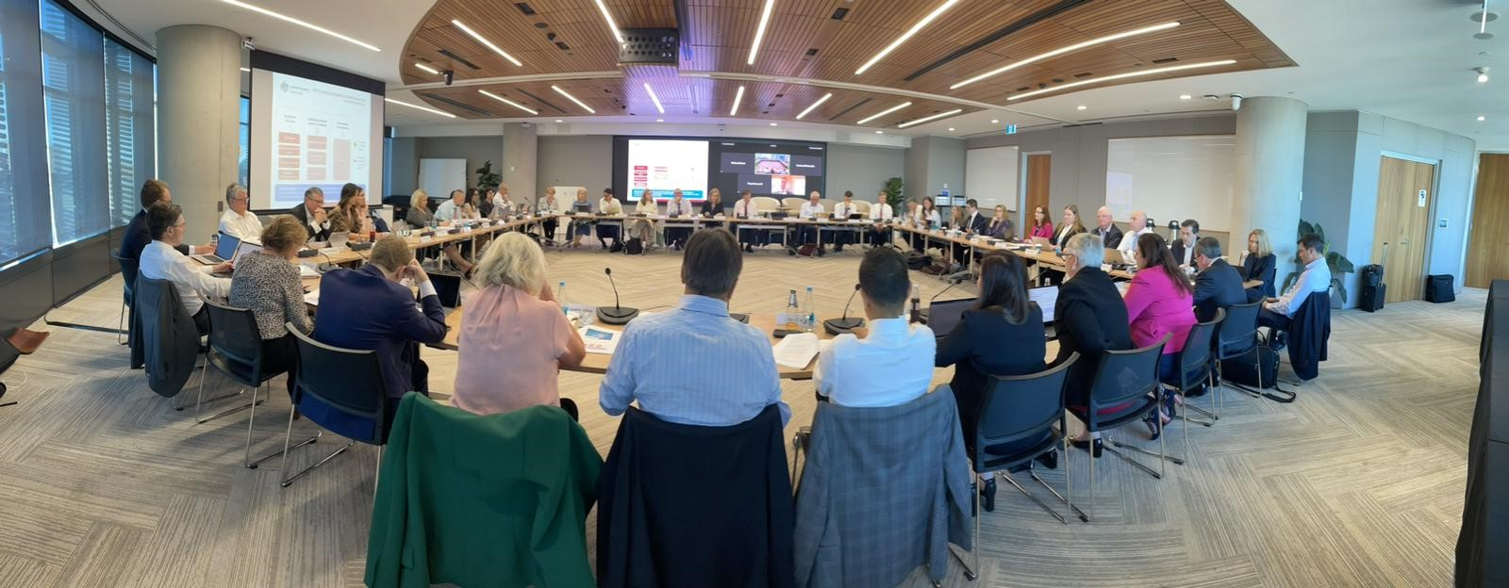

Panel members meeting in Sydney for the November 2022 Panel Day.

## Guidance

The Panel publishes Guidance Notes to assist the market in relation to takeovers matters and to assist Panel members make consistent decisions.

Guidance Notes are generally developed by sub‑committees of Panel members. Sometimes other market participants are invited to be sub‑committee members. Appendix 2 lists sub‑committee members. The Panel thanks them for their contributions.

## Consultation

In addition to post matter reviews (see below), the Panel undertakes public consultation in relation to policy or procedural issues. The Panel may approach interest groups if they are likely to be materially affected or may provide specialised input. The Panel publishes all submissions. The Panel also publishes a response to submissions addressing the main comments received and the reasons for adopting or rejecting them. For more information see the section ‘Public consultations process’ under ‘Consultations’ on the Panel’s website.

In the current period the Panel published two consultation papers.

Table 6: Consultation papers issued, 2022–23

|  |  |  |  |
| --- | --- | --- | --- |
| Consultation Paper | Issue Date | Close Date | Number of submissions |
| GN 19 – Insider participation in control transactions | 14/12/2022 | 28/02/2023 | 7 |
| GN 7 – Deal protection | 14/12/2022 | 28/02/2023 | 9 |

## Legislation

The Panel operates under the Corporations Act and ASIC Act.

## Judicial review

There were no judicial reviews of the Panel’s decisions this financial year.

# Part 4 – Performance Reporting

## Matter reviews

Panel decisions are discussed at Panel days. The Panel also invites parties to participate in a post matter review after a matter has concluded (one post matter review was held in 2022–23).

## Industry liaison

The Panel executive liaises with the major regulators in the takeovers area in Australia and overseas. Liaison with Australian regulators (ASIC, with which the Panel executive has an MOU, ASX and FIRB) ensures that the Panel has effective working relations and its regulatory role fits appropriately with theirs. The Panel executive holds regular liaison meetings with ASIC staff to discuss policy developments and recent issues.

The Panel executive contributes to the Asia Pacific Takeovers Regulators Forum.

The Panel also maintains contact with organisations such as the Business Law Section of the Law Council of Australia. Panel members and the executive also attend and speak at industry meetings, education sessions and seminars.

## Referrals to ASIC

ASIC is involved in every application. Matters might be specifically referred to ASIC because:

* a sitting Panel considers that ASIC should look into aspects of the application that might give rise to concerns under the Corporations Act generally
* the Panel wants ASIC to consider whether to make an application.[[24]](#footnote-25)

There was one referral made during the current period.

## Website

The Panel uses its website (www.takeovers.gov.au) to maintain a market presence, inform, invite contact, publish documents and undertake policy consultation. During the financial year, 127,260 people visited the Panel’s website and there were 351,872 page views.

## Announcements and media releases

Panel decisions are available through the Panel’s website or RSS feed.

If the entity involved in a Panel matter is listed, the Panel’s media releases in relation to that matter are also made available on the ASX website or the relevant Australian securities exchange.

## Corporate governance

### Planning and review

The executive holds regular operational review meetings with the President and Treasury.

Executive staff performance is reviewed as part of Treasury’s performance appraisal program.

The APS Values and Code of Conduct apply to the executive and, in certain circumstances, Panel members.

### Fraud control

The Panel is covered by Treasury’s Fraud and Corruption Control Plan 2021–2023.

### Risk management

The Panel maintains a risk register and major risks are reviewed monthly.

## Outcome and output information

### Organisational budget

The Panel’s funding is included in Treasury‘s budget. The Panel relies on Treasury’s administrative infrastructure and processes.

### Treasury accountability

The Chief Executive provides monthly reports on financial and operational issues to the President and to the Deputy Secretary, Markets Group in Treasury.

### Outcome and program structure

In the current period, the Panel’s functions contributed to Treasury’s Outcome 1: *‘Supporting and implementing informed decisions on policies for the good of the Australian people, including for achieving strong, sustainable economic growth, through the provision of advice to Treasury Ministers and the efficient administration of Treasury’s functions.’*

The Panel’s outputs contribute to Treasury’s Program 1.1: Department of the Treasury.

Table 7: Summary resource statement

|  |  |  |  |
| --- | --- | --- | --- |
|  | Actual budget allocation | Expenses | Balance remaining |
|  | 2022–23 ($’000) | 2022–23 ($’000) | 2022–23 ($’000) |
| Revenue |  |  |  |
| Revenue (Department of the Treasury budget allocation and section 74 relevant agency receipts) | 2,800 | 2,498 | 302 |
| Total resourcing | 2,800 | 2,498 | 302 |

|  |  |  |
| --- | --- | --- |
|  | 2022–23 | 2023–24 |
| Average staffing levels (number) | 7.9 | 8.0 |

### Treasury outcome

The Panel contributes to Treasury’s outcome by:

* timely, clear and consistent decisions in line with market practice
* guidance to assist market participants regarding takeover aspects of the Corporations Act and ASIC Act (including seeking public consultation from market participants)
* procedural rules for fair, timely and cost‑effective resolution of disputes.

## Financial information

### Schedule of Revenues and Expenditures

Table 8: Income statement (Showing Net Cost of Services) (unaudited) for the year ended 30 June 2023

|  | $ |
| --- | --- |
| NET COST OF SERVICES |  |
| Employee expenses |  |
| Salaries | 1,349,662 |
| Employer superannuation | 193,916 |
| Members’ annual retainer and sitting fees | 534,062 |
| Total employee expenses | 2,077,640 |
| Operating expenses |  |
| Consultants | 103,070 |
| Travel | 93,296 |
| Contractors | 76,496 |
| Legal | 70,146 |
| Publications and subscriptions | 27,813 |
| General Office | 27,197 |
| Conferences and training | 22,076 |
| Total operating expenses | 420,094 |
| Total expenses incurred to 30 June 2023 | 2,497,734 |
| Own source income | – |
| Net cost of services | ‑2,497,734 |
| Revenue (Department of the Treasury budget allocation) | 2,800,000 |
| Surplus/(Deficit) | 302,266 |

### Audit

The Panel is a division of the Treasury. Treasury’s financial statements are subject to audit by the ANAO. The Panel’s operations are also subject to review under Treasury’s internal audit program.

### Notes to the Schedule of Revenues and Expenditures

#### Statement of accounting policies

The significant accounting policies that have been adopted in the preparation of this financial information are:

##### Basis of preparation

The financial information is special purpose financial information and is required under section 183 of the ASIC Act.

The financial information has been prepared on an accruals basis.

##### Revenue

Revenue represents the Panel’s budget allocation of Treasury’s appropriation (revenue from Government) for the financial year. Other revenue represents retained revenue receipts under section 74 of the *Public Governance, Performance and Accountability Act 2013*.

##### Expenses

Expenses are recognised on an accruals basis. Expenses only relate to the direct costs of the Panel.

##### Surplus

The surplus represents the Panel’s underspend against its budget allocation for the   
2022–23 financial year.

##### Salaries and members’ annual and sitting fees

Salaries and member sitting fees are recognised as they occur.

Salaries for the current financial year include payments to firms for secondees’ services. The payments are treated as payments for employees, not consultants.

##### GST

Revenues and expenses are recognised net of goods and services tax.

# Part 5 – Management and Accountability

## External scrutiny

Panel decisions in relation to unacceptable circumstances and orders are subject to internal review by another Panel.[[25]](#footnote-26) All Panel decisions are subject to judicial review.[[26]](#footnote-27) However, most reviews of Panel decisions end with the review Panel process.

See Table 15 for a breakdown of Panel review proceedings.

### Government scrutiny

The Panel was not subject to any reports by the ANAO in 2022–23.

The Panel attends hearings of the Senate Standing Committee on Economics Estimates and the Parliamentary Joint Committee on Corporations and Financial Services as required.[[27]](#footnote-28)

### Ombudsman

The Panel was not aware of any reports by the Commonwealth Ombudsman in 2022–23 in relation to the Panel.

## Management of human resources

### Staffing

At 30 June 2023, the executive consisted of six permanent staff (one on long term leave), two non‑ongoing staff and one legal secondee.[[28]](#footnote-29) Permanent staff are employed under the *Public Service Act 1999* (Cth)*.*

Table 9: Operative staff by classification and gender[[29]](#footnote-30)

|  | Full time | | Part time | |
| --- | --- | --- | --- | --- |
| Classification | Male | Female | Female | Total |
| APS4 |  | 1 |  | 1 |
| APS6 |  | 1 |  | 1 |
| EL2 | 2 | 1 | 1 | 4 |
| SEB1 | 1 |  |  | 1 |
| SEB2 |  | 1 |  | 1 |
| Total | 3 | 4 | 1 | 8 |

Note: Acronyms in the table can be found in Appendix 4.

### Secondments

The small number of permanent staff on the executive is supplemented by secondees from law firms, other professional firms or ASIC. The Panel executive organises functions and meetings with former staff and secondees, in part for succession planning purposes.

### Staff development

The Panel seeks to ensure that its staff develop their core skills. Legal staff are encouraged to attend legal and commercial training and conferences. Non‑legal staff are encouraged to attend training, including in relation to management and administration.

### Executive remuneration

As Panel executive staff are Treasury employees, information about executive remuneration can be found in Treasury’s Annual Report (Part 3: Management and Accountability).

The Panel did not make any specific performance payments or bonus payments.

### Remuneration for non‑SES

The Treasury Enterprise Agreement 2018–21 determines salary rates for non‑SES staff, the agreement was subject to a determination under Section 24(1) of the *Public Service Act 1999* to provide annual wage increases to 4 November 2024. Details and statistics on non‑SES remuneration are included in Treasury’s Annual Report (Part 3: Management and Accountability).

### Workplace diversity

The Panel values diversity and benefits from Treasury’s Inclusion and Diversity Strategy 2019–21 and the development of Treasury’s next Inclusion and Diversity Strategy is underway. Details and statistics on workplace diversity are included in Treasury’s Annual Report (Part 3: Management and Accountability).

### Industrial democracy

Panel staff utilise Treasury’s Performance Development System and Integrated Leadership System. Treasury’s Workplace Relations Committee deals with industrial democracy issues.

### Work Health and Safety

Panel staff have the benefit of Treasury‘s Work Health and Safety Management System. Services provided to the Panel for the year included flu injections for the Panel executive. There were no reported accidents or dangerous occurrences during the year.

The Panel utilises Treasury’s Employee Assistance Program, an external and confidential counselling service for Treasury staff and their families.

### Commonwealth disability strategy

#### Disability reporting mechanism

Australia’s Disability Strategy 2021–2031 is the overarching framework for inclusive policies, programs and infrastructure that will support people with disability to participate in all areas of Australian life. The Strategy sets out where practical changes will be made to improve the lives of people with disability in Australia. It acts to ensure the principles underpinning the United Nations Convention on the Rights of Persons with Disabilities are incorporated into Australia’s policies and programs that affect people with disability, their families and carers. All levels of government have committed to deliver more comprehensive and visible reporting under the Strategy. A range of reports on progress of the Strategy’s actions and outcome areas will be published and available at [disabilitygateway.gov.au/ads](https://www.disabilitygateway.gov.au/ads)

Disability reporting is included the Australian Public Service Commission’s State of the Service reports and the APS Statistical Bulletin. These reports are available at [apsc.gov.au](http://www.apsc.gov.au/).

## Purchasing

The Panel follows Treasury’s procurement framework to ensure that it undertakes competitive and non‑discriminatory tendering and quoting processes which are designed to result in value for money.

All proposed procurements valued at $10,000 or more were reviewed by Treasury’s Procurement Team.

During the current period the Panel entered into six contracts that each exceeded $10,000. These related to two secondment agreements, two contractors, one IT project and one online research tool.

## Consultants

During 2022–23, the Panel had a fee for service contract with a web design firm to redevelop the Panel’s website.

## Small business

The Panel supports small business participation in the Commonwealth Government procurement market. Small and Medium Enterprises (SME) and Small Enterprise participation statistics are available on the Department of Finance’s website – www.finance.gov.au.

## Discretionary grants

The Panel did not make any discretionary grants in 2022–23.

## Advertising and market research

The Panel did not undertake any advertising or market research during 2022–23.

## Environmental performance

The Panel follows Treasury’s Environmental Management Plan. Details on actions taken in relation to ecologically sustainable development and environmental performance are included in Treasury’s Annual Report (Part 5: Appendices – Ecologically sustainable development and environmental performance).

## Freedom of information

Entities subject to the *Freedom of Information Act 1982* (Cth) (FOI Act) are required to publish information to the public as part of the Information Publication Scheme (IPS). This requirement is in Part II of the FOI Act and has replaced the former requirement to publish a section 8 statement in an annual report. Each agency must display on its website a plan showing what information it publishes in accordance with the IPS requirements. The Panel’s IPS can be found on its website.

## Regulatory Impact Statements

The Panel did not submit any Regulatory Impact Statements in 2022–23.

# Appendix 1 – Panel members

Table 10: Members of the Panel at 30 June 2023

|  |  |
| --- | --- |
| Mr Alex Cartel (President) | Mr Jeremy Leibler |
| Ms Yasmin Allen AM | Mr Michael Lishman |
| Mr Kelvin Barry | Mr Timothy Longstaff |
| Mr Robin Bishop | Ms Sandy Mak |
| Mr Carl Blanchard | Mr Ron Malek |
| Mr Michael Borsky KC | Ms Rebecca Maslen‑Stannage |
| Mr Constantine Boulougouris | Ms Denise McComish |
| Mr James Burchnall | Mr John McGlue |
| Ms Stephanie Charles | Mr Bruce McLennan |
| Mr Alberto Colla | Mr Rory Moriarty |
| Mr Bruce Cowley | Ms Kerry Morrow |
| Ms Chelsey Drake | Ms Emma‑Jane Newton |
| Ms Teresa Dyson | Ms Diana Nicholson |
| Ms Sylvia Falzon | Mr Tony Osmond |
| Mr Joseph Fayyad | Mr John O’Sullivan |
| Ms Marissa Freund | Mrs Deborah Page AM |
| Ms Elizabeth Hallett | Mr Neil Pathak |
| Ms Louise Higgins | Ms Karen Phin |
| Dr Ruth Higgins SC | Ms Sarah Rennie |
| Ms Tracey Horton AO | Mr John Sheahan KC |
| Mr Richard Hunt | Mr James Stewart |
| Ms Michelle Jablko | Ms Philippa Stone |
| Mr Christian Johnston | Ms Erin Tinker |
| Ms Kristen Jung | Ms Kate Towey |
| Ms Marina Kelman | Ms Nicola Wakefield Evans AM |
| Mr Bill Koeck | Ms Sharon Warburton |

Table 11: Members appointed to the Panel in 2022–23

|  |  |
| --- | --- |
| Mr Carl Blanchard | Ms Emma‑Jane Newton |
| Ms Sylvia Falzon | Dr Kristina Stern SC |
| Mr Joseph Fayyad | Ms Erin Tinker |
| Ms Louise Higgins | Ms Kate Towey |
| Dr Ruth Higgins SC |  |

Table 12: Members who ceased their membership of the Panel in 2022–23

|  |  |
| --- | --- |
| Ms Paula Dwyer | Mr Robert McKenzie |
| Ms Karen Evans‑Cullen | Ms Tara Page |
| Mr Ian Jackman SC | Dr Kristina Stern SC |
| Mr Anthony Jarvis | Mr David Williamson |

# Appendix 2 – Sub‑committee members

Table 13: Sub‑committees

| Topic | Sub‑committee members | |
| --- | --- | --- |
| Panel member | External member |
| GN 19 Insider Participation | Mr Alex Cartel (President) | Ms Karen Evans‑Cullen |
|  | Ms Stephanie Charles |  |
|  | Ms Marissa Freund |  |
|  | Mr Bill Koeck |  |
|  | Mr Ron Malek |  |
|  | Ms Diana Nicholson |  |
|  | Mr Neil Pathak |  |
| GN 7 Deal protection | Mr Alex Cartel (President) | Ms Karen Evans‑Cullen |
|  | Mr Kelvin Barry |  |
|  | Mr Bruce Cowley |  |
|  | Ms Diana Nicholson |  |
|  | Mr Neil Pathak |  |
|  | Mr James Stewart |  |
|  | Ms Nicola Wakefield Evans |  |

# Appendix 3 – Panel Applications

Table 14: Applications received by the Panel in 2022–23[[30]](#footnote-31)

|  | Matter No. | Section | Matter name | Decision | Application Date | Decision date | Days to Decision |
| --- | --- | --- | --- | --- | --- | --- | --- |
| 1 | 2022/17 | 657A,D,E | Moreton Resources Limited 03 | Declined to conduct proceedings | 05/07/2022 | 12/07/2022 | 7 |
| 2 | 2022/18 | 657A,D,E | Firetail Resources Limited | Declined to conduct proceedings | 27/07/2022 | 16/08/2022 | 20 |
| 3 | 2022/19 | 657A,D,E | Nimrod Resources Limited 02 | Declined to conduct proceedings | 23/09/2022 | 06/10/2022 | 13 |
| 4 | 2022/20 | 657A,D,E | Mineral Commodities Limited 02 | Declaration and undertaking | 17/10/2022 | 28/11/2022 | 42 |
| 5 | 2022/21 | 657A,D,E | CD Private Equity Fund II | Declined to conduct proceedings, action by party | 27/10/2022 | 14/11/2022 | 18 |
| 6 | 2022/22 | 657A,D,E | Lincoln Minerals Limited 02 | Conducted proceedings, no declaration, action by party | 27/10/2022 | 29/11/2022 | 33 |
| 7 | 2022/23 | 657A,D,E | Lincoln Minerals Limited 03 | Conducted proceedings, no declaration, action by party | 31/10/2022 | 29/11/2022 | 29 |
| 8 | 2022/24 | 657EA | Lincoln Minerals Limited 04R | Conducted proceedings, no declaration | 01/12/2022 | 04/01/2023 | 34 |
| 9 | 2023/01 | 657A,D | Nitro Software Limited | Conducted proceedings, no declaration | 04/01/2023 | 23/01/2023 | 19 |

Table 14: Applications received by the Panel in 2022–23 (continued)

|  | Matter No. | Section | Matter name | Decision | Application Date | Decision date | Days to Decision |
| --- | --- | --- | --- | --- | --- | --- | --- |
| 10 | 2023/02 | 657A,D,E | Nitro Software Limited 02 | Conducted proceedings, no declaration, action by party | 09/01/2023 | 08/02/2023 | 30 |
| 11 | 2023/03 | 657A,D | AIMS Property Securities Fund 03 | Conducted proceedings, no declaration | 21/01/2023 | 01/03/2023 | 39 |
| 12 | 2023/04 | 657EA | Nitro Software Limited 03R | Conducted proceedings, no declaration | 24/01/2023 | 09/02/2023 | 16 |
| 13 | 2023/05 | 657A,D,E | The Market Herald Limited | Declaration and orders | 06/02/2023 | 18/05/2023 | 101 |
| 14 | 2023/06 | 657A,D,E | Healius Limited | Declined to conduct proceedings, action by party | 28/03/2023 | 14/04/2023 | 17 |
| 15 | 2023/07 | 657A,D,E | ASP Aluminium Holdings Pty Limited | Conducted proceedings, no declaration | 02/05/2023 | 26/05/2023 | 24 |
| 16 | 2023/08 | 657EA | ASP Aluminium Holdings Pty Limited 02R | Conducted proceedings, no declaration | 30/05/2023 | 23/06/2023 | 24 |

Table 15: Outcomes of review applications received by the Panel in 2022–23

|  | Matter No. | Review matter name | Matter reviewed | Review outcome |
| --- | --- | --- | --- | --- |
| 1 | 2022/24 | Lincoln Minerals Limited 04R | Lincoln Minerals Limited 02 & 03 | Affirmed Panel decision |
| 2 | 2023/04 | Nitro Software Limited 03R | Nitro Software Limited | Affirmed Panel decision |
| 3 | 2023/08 | ASP Aluminium Holdings Pty Limited 02R | ASP Aluminium Holdings Pty Limited | Affirmed Panel decision |

# Appendix 4 – Abbreviations and acronyms

|  |  |
| --- | --- |
| AICD | Australian Institute of Company Directors |
| ANAO | Australian National Audit Office |
| APS | Australian Public Service |
| ASIC | Australian Securities and Investments Commission |
| ASX | ASX Limited |
| EL | Executive Level |
| FIRB | Foreign Investment Review Board |
| M&A | Mergers and Acquisitions |
| MOU | Memorandum of Understanding |
| SEB | Senior Executive Band |
| SES | Senior Executive Service |
| Treasury | Commonwealth Department of the Treasury |

# Index

A

Acting Presidents 10

Applications 6, 20, 22, 39, 40

Australian Securities and Investments Commission Act 2001 (Cth) 24

C

Consultants 34

Corporate governance 26

Corporations Act 2001 (Cth) 1, 24

D

Decision 6, 21

Disability 33

Discretionary grants 34

E

Enquiries 2

Environmental performance 34

Executive 10, 31

External scrutiny 31

F

Financial information 28

Freedom of information 35

G

Gender 14

Guidance 7, 23

I

Industrial democracy 33

J

Judicial review 24

L

Legislation 24

Location 13

M

Management and accountability 31

Management of human resources 31

Matters 6, 19

O

Organisational structure 9

Outcome and output information 26

P

Panel members 12, 15, 36

President 3, 9

Price of agency outputs 27

Profession 13

Purchasing 34

R

Regulatory Impact Statements 35

Remuneration 32

Review of a Panel decision 8, 40

Review of ASIC decisions 7, 8

S

Secondments 32

Small business 34

Staff development 32

Staffing 31

Sub-committee members 38

T

Treasury 26, 27, 28, 33

W

Website 26

Work Health and Safety 33

Workplace diversity 33

1. Section 172(4) of the ASIC Act. [↑](#footnote-ref-2)
2. Paragraph [7.16] of the Explanatory Memorandum for the Corporate Law Economic Reform Program Bill 1998 (Cth). [↑](#footnote-ref-3)
3. Section 659AA of the Corporations Act. [↑](#footnote-ref-4)
4. Renamed to Deal protection on 8 August 2023 [↑](#footnote-ref-5)
5. Cemex Australia Pty Ltd v Takeovers Panel [2009] FCAFC 78 at [81] to [89], quoting extensively from Attorney‑General (Cth) v Alinta Ltd Limited [2008] HCA 2 [↑](#footnote-ref-6)
6. A breakdown of days from application and decision is in Table 4: Time to decision by the Panel,   
   2022–23. [↑](#footnote-ref-7)
7. Section 657A and, if a declaration is made, orders under section 657D. [↑](#footnote-ref-8)
8. Under section 655A and, during a takeover bid, section 673 (see section 656A). [↑](#footnote-ref-9)
9. Section 656A(3). [↑](#footnote-ref-10)
10. Section 9. However, it cannot make an order directing a person to comply with a requirement of  
    Chapters 6 – 6C. [↑](#footnote-ref-11)
11. Only with consent of the President if the initial Panel did not make a declaration or orders. See generally section 657EA. [↑](#footnote-ref-12)
12. Section 658C. [↑](#footnote-ref-13)
13. Section 195 of the ASIC Act. [↑](#footnote-ref-14)
14. Section 657EB. [↑](#footnote-ref-15)
15. Section 173 of the ASIC Act. [↑](#footnote-ref-16)
16. Sections 182(1)(a)&(b) of the ASIC Act. [↑](#footnote-ref-17)
17. Section 172 of the ASIC Act. [↑](#footnote-ref-18)
18. Section 172(4A) of the ASIC Act. [↑](#footnote-ref-19)
19. Regulations 35 to 41 of the ASIC Regulations. [↑](#footnote-ref-20)
20. Section 192 of the ASIC Act. [↑](#footnote-ref-21)
21. Section 201A of the ASIC Act. [↑](#footnote-ref-22)
22. Average days to decision for each time band. For example the average days to decision for the matters that were decided between 15 and 31 days was 21.9 days. [↑](#footnote-ref-23)
23. An extension of time was obtained from the Court in relation to this matter under section 657B [↑](#footnote-ref-24)
24. Regulation 18 of the ASIC Regulations. [↑](#footnote-ref-25)
25. Section 657EA. A decision that is not a decision to make a declaration, an interim order or a final order can only be reviewed under this section with the President’s consent. [↑](#footnote-ref-26)
26. Section 75(v) of the Constitution, the *Judiciary Act 1903* and the *Administrative Decisions (Judicial Review) Act 1977*, see page 23 for details about current judicial reviews of Panel decisions. [↑](#footnote-ref-27)
27. See Parliamentary Joint Committee on Corporations and Financial Services, Report on the 2021–‍2022 annual reports of bodies established under the ASIC Act. Pages 3 to 8 of the report discuss the Takeovers Panel. [↑](#footnote-ref-28)
28. The Panel also engaged two senior lawyers as contractors for a period. [↑](#footnote-ref-29)
29. No employees identified themselves as Indigenous at 30 June 2023. [↑](#footnote-ref-30)
30. Under sections 657C and 657EA. [↑](#footnote-ref-31)